Advanced soil fertility and fertilizers FOR MASTERS Degree 2023-2024
Soil department and water resources
First lecture
NITROGEN

Introduction
Nitrogen occurs in many forms in agricultural ecosystems
Why ??
Because Nitrogen can exist in a number of valence states within an ecosystem.( how can happened ?)
The valence state in which nitrogen exists depends primarily on the ambient environment at micro-sites within the soil
The transformations and flow of nitrogen from one valence state to another constitute .

For example ,
N₂ atmospheric (78%),
( 0 charge ) gas is converted by lightening to various oxides and finally to nitrate NO₃⁻¹ ( +5 charge ) , which falls with the rain and Is taken up by growing plants
Also ,
N₂ gas can be converted to ammonia(NH₃) (3charge) by microbial fixation , with NH₂ being used in various biochemical reactions within plants .
When plant residues decompose, much of the N they contain will undergo several Microbial conversion and will eventually end up back As nitrates
Also,
Under anaerobic conditions , nitrates can be reduced to various oxides and Ultimately to N₂ gas again .
Nitrogen in inputs such as fertilizers and manures is also subjected to these same Microbial transformations .

Globally where can N in the biosphere show ?
As table 8.1 : referred to global inventories of nitrogen in biosphere(million mg N) ) المخزون العالمي للنتروجين في المحيط الحيوي )
There are three main resources for nitrogen as table 8.1
At three phases ( solid , liquid and gases )
- Terrestrial include----
- Oceanic ----
- Atmospheric ----

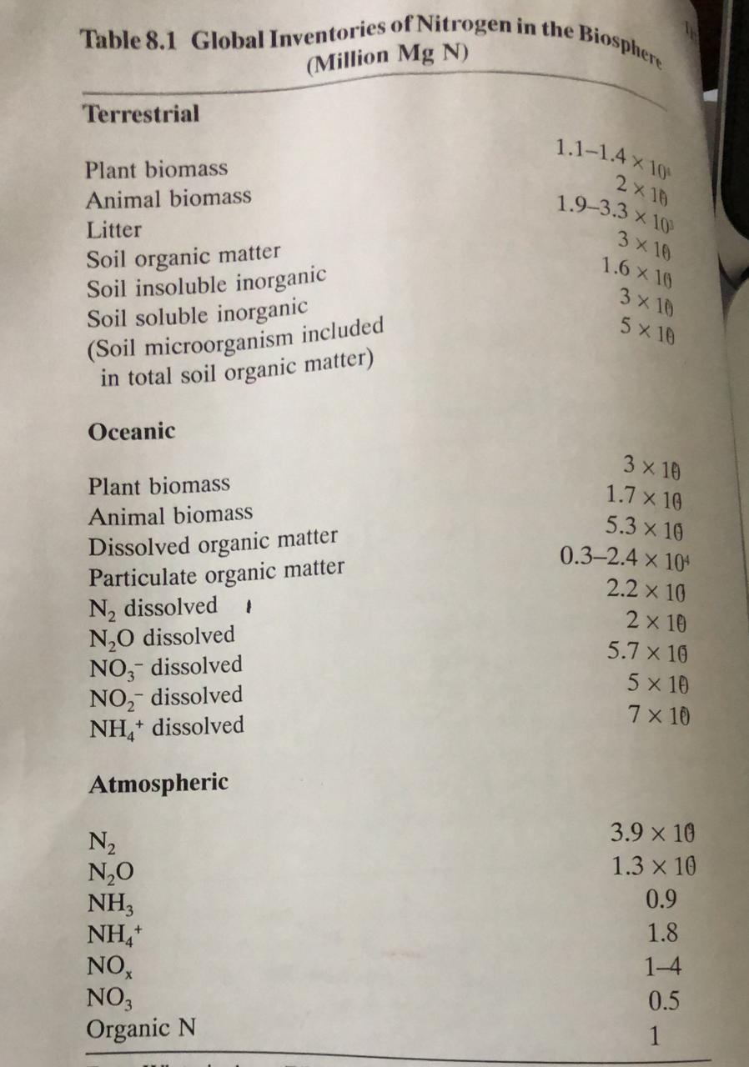
N is distributed in terrestrial , oceanic and atmospheric components
Note ,
The bulk of biosphere -N is in atmosphere , the atmosphere column hectare of on an land will contain approximately 8.4*10 ⁴ mg ha⁻¹ N
Yet , for growing most cereals and nonlegume forage crops
So, has to apply large amounts of manure and / or fertilizer N
Nitrogen in soil originates from plants and animals residues , from fixation By leguminous plants and trees.
Total N content in the top 15 to 20 cm of surface soil ranges from 0.01 % to more than 2.5% in peat
N content in the subsurface of any soil is generally less than in the surface Layer , since most organic residues are deposited on soil surface Under suitable conditions some of organic legume mineralized Into inorganic form and may be present in ammonium (NH₄⁺ ) and nitrate (NO₃⁻ ) form .

Soil organic N
Soil organic N consists of proteins (20-40%) , amino sugars such as purine and pyrimidine (1%or Less) and condensation Of sugar and amines .
part of organic -N is also present as clay -humus complexes , which are resistant to decomposition .
So ,
This would explain why only a very small part of immobilized Fertilizer N becomes available to growing crop plants

